http://blog.mycvfactory.com/wp-content/uploads/2014/11/Mycvfactory-Positif-cv-moderne-0.jpg

|  |  |  |  |
| --- | --- | --- | --- |
| |  | | --- | | Asad Mahmand  Director Information Systems  www.DatumSquare.com | | Languages: English, Urdu and Pashto.  Address: House No 171, Street 19, Block D, PWD Colony, Islamabad.  Mobile: +92-3339372433  E-mail: [asadmahmand@gmail.com](mailto:asadmahmand@gmail.com) | |  |

I have over 10 years of experience in different network related fields. I am currently working as Directory Information Systems at DatumSquare IT Services. I have Experience of working on verity of projects related to Web Servers, Databases, Networks, Data Security and Backups. I have helped Setup several companies Servers and Network infrastructure. I am coordinating with US Based clients on daily basis at my office. I am considered to be a problem solver in complex and Applications interrelated complications. I am proficient in English and have done IELTS.

Experience

Feb 2011 to Present

DatumSquare IT services is known as Allshore in US.

1. Feb 2012 -- Present

www.allshore.us is a US based company with Clien Management Office in Norman, Oklahoma US, Main office at STP3 I9/3 Islamabad and sub office in Siddiq Trade Center Lahore. Our company is known by Allshore in US and registered as Datum square in Pakistan. I am over all in charge of all IT related operations which include all three office servers and network management, our US based and Pakistan Cloud Servers Management, management of IT team and projects, IT policies and purchase of equipment. I have built the Islamabad office from

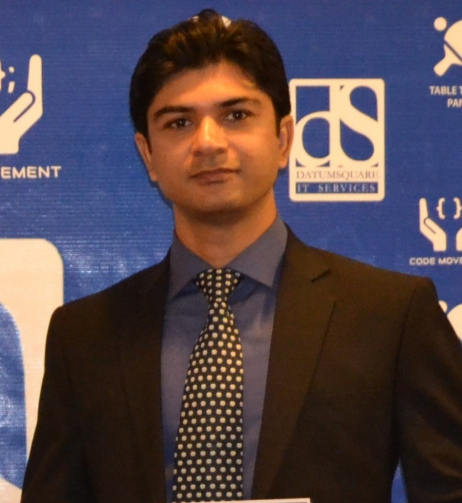

scratch which has capacity of about 150 users managed by Active Directory servers, mails managed by Exchange 2010, Virtualmin based SVN Linux servers, Windows TFS servers, Norton Backup exec as backup server, Norton

endpoint protection as centralize Antivirus, with Cisco Router as gateway and Cisco smart switches as Network backbone. VMware workstation is used to efficiently use the servers. At Oklahoma we have a cloud provider and I have built all the windows and Linux Web servers for the our clients there. I am also managing a team of network support agents who are providing network support to a ISP in USA.

Some websites of Our Network:

[Datumsquare.com](http://www.dubaimoon.com/) | [Allshore.us](http://www.dxbsouq.com/) | [Codemovement.pk](http://www.ajeebtv.com/) |

1. Aug 2008 -- Feb 2012

EVAST was a Dubai based Software Company well known in Dubai through there Arabic Web Portal [www.dubaimoon.com](http://WWW.DUBAIMOON.COM). Here I manage their Dedicated servers located in TAXAS USA. Servers ware Red Hat Linux based servers with WHM/Cpanel on which many of our company websites and other clients websites are hosted.

Evast is also a webhosting Company with services like web designing, web development, IT marketing and other IT solutions mentioned at the website www.evast.ae.

Evast has developed and hosted many government websites too.

The most prominent of them is of the Crown Prince Sheikh Hamdan Bin Mohammed Bin Rashid Al Maktoum’s website [www.fazza3.com](http://WWW.FAZZA3.COM).

Designation: Manager IT

Some websites of Our Network:

[DubaiMoon.com](http://www.dubaimoon.com/) | [dxbSOUQ.com](http://www.dxbsouq.com/) | [Evast.ae](http://www.ajeebtv.com/) | [arbb.com](http://www.barzah.com/) | [carssouq.com](http://www.sms2mobily.net/)

1. Aug 2008 -- Feb 2008

In Aug 2008 I was offered a contract job from Allainet and another job from Evast. At Allainet I was contracted to build their Call Center from Scratch. I Configured Asterisk based Call Server with Vicidial and the Predictive Dialer. The call server have all the abilities of a modern soft PBX, like call recording, call logging, call forwarding, call monitoring etc. The full setup of the 50 to 100 seat call center setup was completed in about a month.

1. Oct 2006 -- Aug 2008

In Oct 2006, I was offered the Post of System Administrator from Nettech pvt ltd Islamabad. Nettech is a UK based Software house and Call center. Nettech was another great experience where I was responsible for the whole network and lead the small network team. Here I was also exposed to the world of VOIP.

Designation: System Administrator. (Responsible for the entire network related issues of the office network. Like VOIP, Dedicated Servers and Linux based office network.)

[www.nettechltd.com](http://www.nettechltd.com) | [www.nettechgs.co.uk](http://www.nettechgs.co.uk) | [www.nettechrec.co.uk](http://www.nettechrec.co.uk)

1. Jan 2003 -- Sep 2006

IQRA Net ISP (Internet Service Provider) Peshawar.

Designation: System Engineer.

I was lucky to start my career at the most complex network of an ISP with the team of the best IT Professionals of Pakistan. I have learned a lot there about Networks, Linux, FreeBSD, Routers, Switches, Modems and Telecommunication.

5. Jan 1999 – Dec2001

Worked as a tutor for school children and taught different subjects.

Education

MIT (Master of Information Technology) CGPA 2.9 IQRA UNIVERSITY KARACHI.

With Specialization in System Engineering

B.Sc in 2nd div (1998) from Edwards College Peshawar.

F.Sc in 1nd div (1995) from Edwards College Peshawar.

Skills

Operating Systems used: CentOS, Redhat, Ubuntu, Suse, Windows 2003, Windows 2008 R2, Windows 20012 R2

Managed Servers and coordinated on projects with Providers like:   
Godaddy, Softlayer, IWeb, HostDime, DigitalOcean, AWS, Azure, RackSpace and many others.

Network Designs, IT inventory management, Standard office procedures for IT, IT Team management, ITIL based IT management including; Service Catalogue Management, Availability Management, Capacity Management, Information security Management and supplier management.

* LAN Equipment Installation and WAN Connectivity. Internet sharing solution Windows and Linux based. Worked on different ISP routers/modems and there configuration for the office environment for different services like port forwarding, DMZ host, IP routing, Dhcp or static IP settings etc.
* Internet Security And Websites Security is a main concern for big websites specially in Middle East due to the loop holes of the website coding. I have experience to configure apache according to the websites residing on the server and other security measures for websites Security;

Config Server’s CXS and CSF Linux Firewall with manually configured options according to the requirements of the websites hosted.

Mod Security which works as a firewall for specially the web traffic of Apache and protect the mysql injections, XSS and other code security holes.

Clam Antivirus, scanning web files from virus threats, it is also helpful in harmful hacking codes like PHP c99 shells and Perl backdoor scripts.

Acunetix Web Venerability Scanner to identify the security issues in the website.

* WHM/Cpanel, web host manager cPanel installation, configuration, management. I have worked on Plask control panel too. But I am more satisfied with my work and control on cPanel.
* MySQL Server configuration and tuning to set according to the load, integration of db connections, running scripts, dumps, backups etc.
* Expert in Backup exec 2010 and 2013,
* Exper in VMWare work station and Esxi and HyperV.
* Expert in Norton backup exec 2010 and 2014.
* Expert in Windows 2012 Active directory administration, Exchange 2010 and 2013.
* Expert in Installation and configuration of Apache Web Server, PHP, MySql, Domain Name Registration, Advanced DNS settings, Web Hosting Pleask and Cpanel based, SSL Certificates Installation (ie; thawte, verisign, godady)
* Worked on Video Streaming Solutions based on FFMPEG, FFServer, Mplayer, Flvtool2, Mencoder, Libogg & Libvorbis etc. Live TV for websites, which takes input from DVB or any other streaming card to the streaming server and it stream it to the website. The integration of live cam to website, in which axis IP cameras are used to provide input to the streaming server and it then streams to website or any other output. I have also worked on Helix Streaming Server and Real Producer of Real Networks for live streaming.
* VOIP/Asterisk Linux server for VOIP services.

FXO/FXS and PRI digum or singoma cards installation

Vicidial predictive dialer for Asterisk

Configured SIP and IAX based connections to UK, USA VOIP service providers like [www.inphonex.com](http://www.inphonex.com), [www.magrathea.com](http://www.magrathea.com), [www.intlno.co.uk](http://www.intlno.co.uk)

Configured ATAs (Analog Telephony Adapter) for VOIP

Configured dialup plans with IVR, Call Queuing, Call Recording, Call Reporting and Voice Mails

* Squid cache and squid guard for limiting web access to specific users.

Work Shops:

* Presented lecture on “DNS importance for websites” in Drupal Camp Nov 2014, organized by [www.drupak.com](http://www.drupak.com) at Datum square Islamabad.
* Presented Lecture on “Apache” in Drupal Camp at 17 Sep 2015, organized by [www.drupak.com](http://www.drupak.com) at Fast University Peshawar.
* Presented a series of lectures on CentOS Linux and Cpanel at Datum square Islamabad office, from Oct 2015 till Nov 2015.

References

1. Mohammad Khurram Manager Networks, Allainet pvt ltd,

Email: [khurram@allainet.com](mailto:khurram@allainet.com) Phone No: 03125092509

1. Mazhar Hussain Manager Systems Telenor Pakistan,

Email: [mazhar_muslim@hotmail.com](mailto:mazhar_muslim@hotmail.com), Phone No: 03458503176